Quick PEP Guide for Foster Carers and Children’s Home Staff

Every looked after child / young person from aged 3 (first term after 3rd birthday) up to the age of 18 require a PEP.
When a child enters care, a PEP has to be completed within 10 school days.
PEPs are completed in the Autumn Term (before the end of October) and are reviewed in the Spring Term (before the end of February) and the Summer Term (before the end of May).

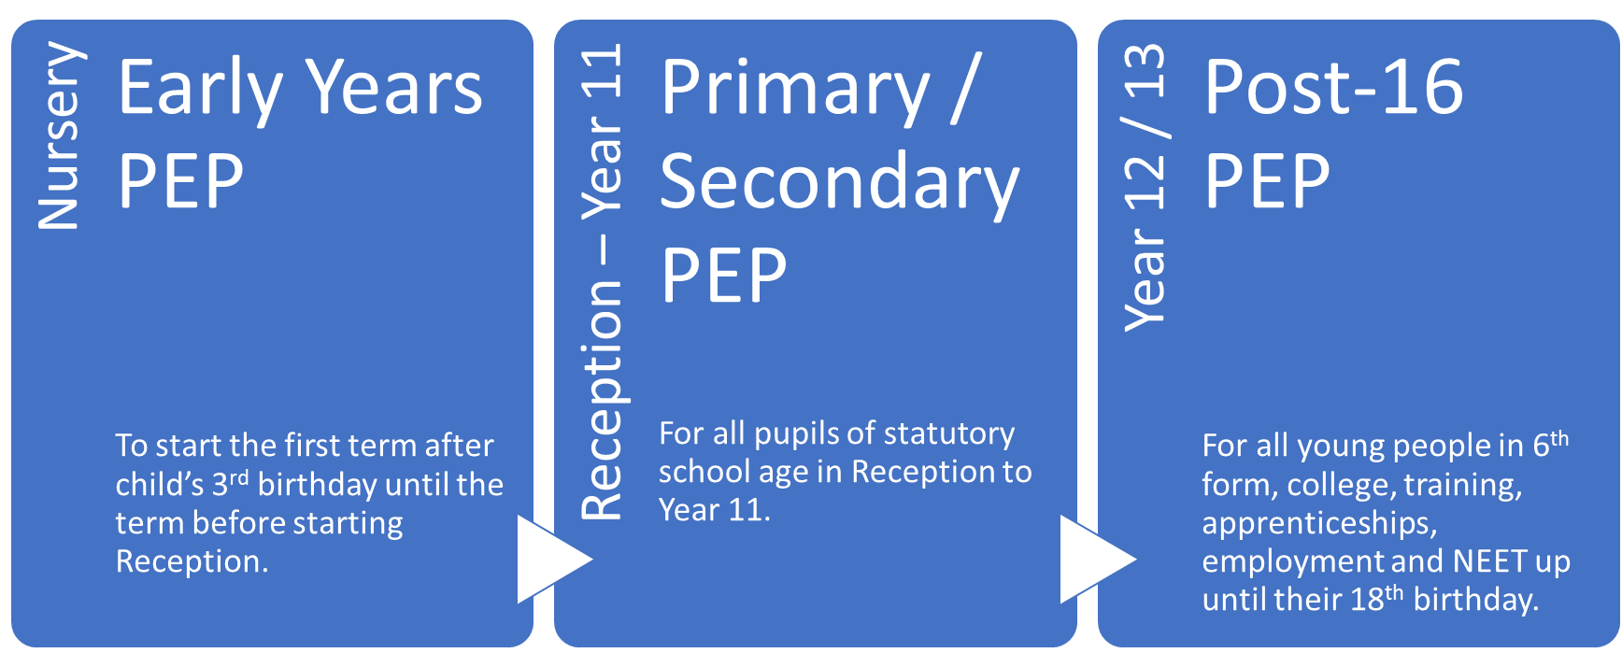
The are 3 different PEPs for different age groups:

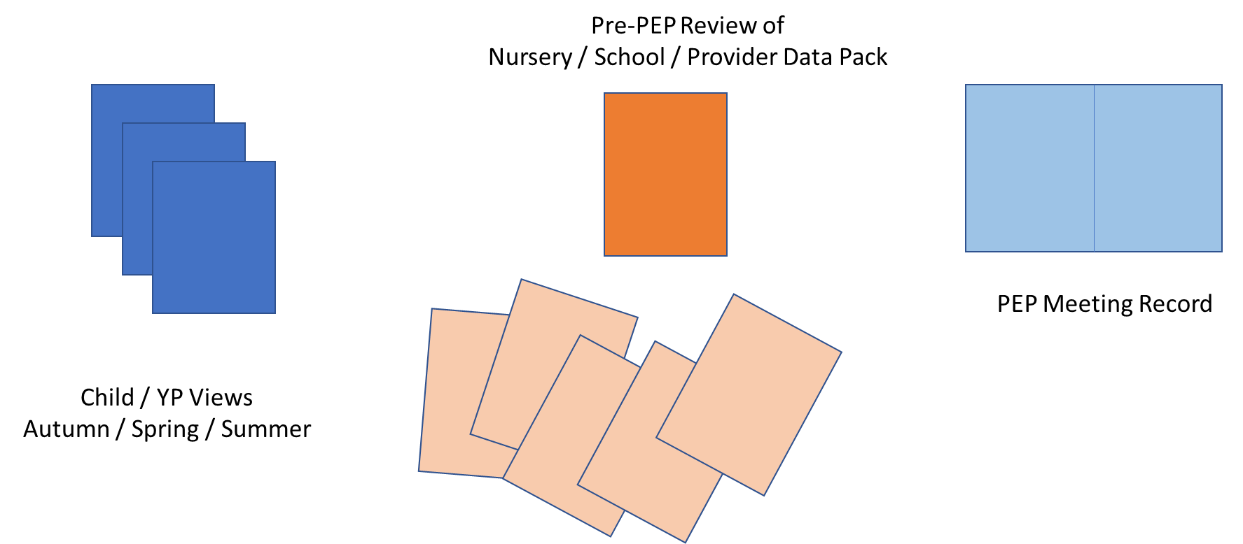
There are three parts to each PEP:

Foster Carer / Children’s Home Staff Role in PEP Process
Prior to PEP Meeting | Agrees date with social worker, school and child / young person (if appropriate) for PEP meeting (Social worker should initiate PEP if child new into care, to be completed within 10 school days)  Speak to child / young person to encourage them to attend meeting and check feelings about school and whether anything they want to raise in meeting.
During PEP Meeting | Attends PEP Meeting. Sets goals and agrees actions with others in meeting.  Agrees date for PEP review (Spring Term / Summer Term)
After PEP Meeting | Completes any actions agreed to achieve goals.

