School Age PEP (Reception to Year 11)
Pupil Views (Version A )
Autumn 2020
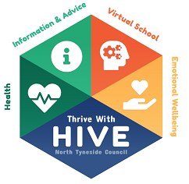
Name:
Date Completed:

What was your education like during Lockdown? Complete the relevant column.
I was mainly in school | I was mainly educated at home
The best thing about being in school was: | The best thing about learning at home was:
I wasn’t so keen on: | I wasn’t so keen on:
The thing I will remember most is: | The thing I will remember most is:

What is going well since returning to school?
Who helps you in school?
Are you able to access online learning from home?
What job would you like to do when you’re older?
Is there anything you are worried or concerned about?

