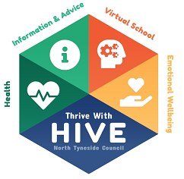
Quick Guide to PEPs for Children and Young People
We want everyone who is in care to do well at school and we want to help you to reach your dreams and ambitions. To help do this you have a Personal Education Plan. Your Personal Education Plan is written in a meeting where you, your carer, your social worker and a member of staff at school discuss how you are getting on in your education (at school, college or training).
Before the meeting you will be asked to complete a short questionnaire or a Three Schools activity to help the people around you to understand how you feel about school and what you’d like to do in the future.
Hopefully, you will want to attend your PEP meeting where you get to talk about what is going well and where you think you might need some help. You and the other people at the meeting decide what your goals will be and how everyone can help you to achieve them.
The main PEP is written at the start of the new school year and then it gets reviewed in the Spring Term and again in the Summer Term to make sure everyone has done what they said they would do to help you make good progress. This includes what you said you’d do too!
There are three parts to each PEP:

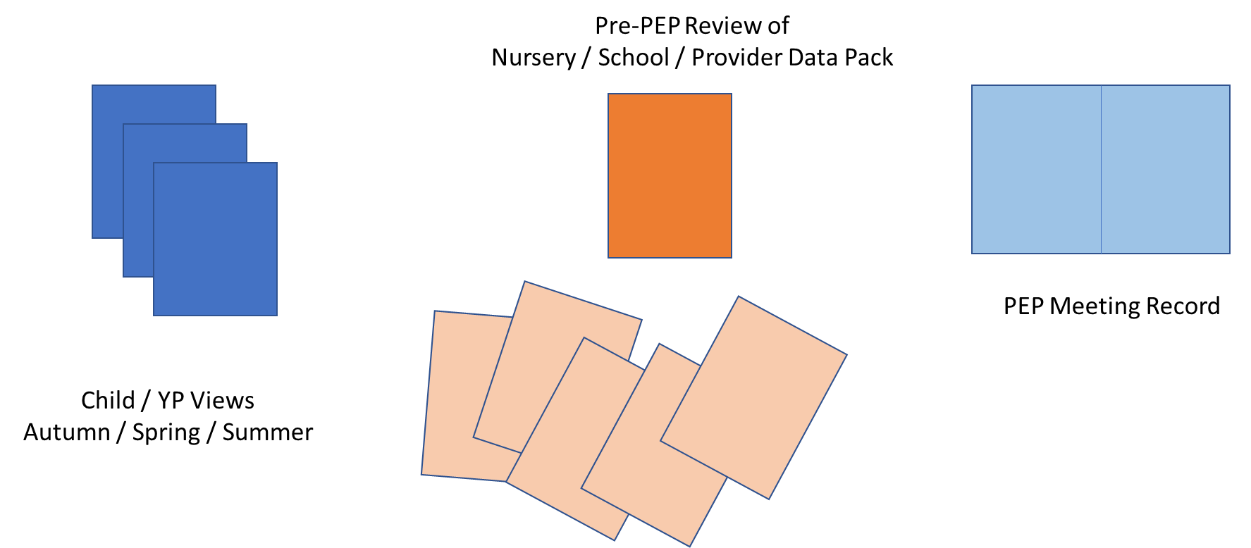
This is your bit!

There are different ways you can give your views about school:
Draw a picture called ‘Me and My School’
Complete the Three Schools – School of Worries, School of Good Things and School of Dreams
Complete a short questionnaire – either an adult will fill it in for you or you can fill it in yourself.

Your role in your Personal Education Plan (PEP)
Prior to PEP Meeting | Thinks about how school / college / training / apprenticeship is going and how the people around you could help you reach your goals and dreams for the future. Complete the Child / Young Person Section of the PEP or tell a teacher what to write on your behalf.
During PEP Meeting | Attend PEP Meeting if you would like to. Sets goals and agrees actions with others in meeting.
After PEP Meeting | Completes any actions agreed to achieve goals.

