The Key Focus in different Year Groups
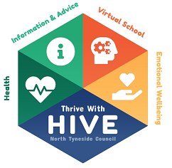
– areas to discuss in PEP Meeting

National Curriculum Year | Key Points
Nursery (Early Years PEP) | Hours being offered? Early Years PP+ £300. Application for Reception (to be completed October)
Reception | Phonics knowledge
Yr 1 | Phonics Test
Yr 2 | SATs – teacher assessments, Phonics resit
Yr 3/4/5 | Is progress and attainment in line with expectations? If in First School – transition at end of Yr 4 to middle school so need to apply for school place.
Yr 6 | Transition to high school – need to apply for school place, SATs
Yr 7 | Settling into high school, enrichment opportunities, peer relationships
Yr 8 / 9 | Choosing options (some schools start KS4 in Yr 9), if in middle school need to apply for Yr 9 school place.
Yr 10 / 11 | GCSEs, Vocational qualification, Work Based Learning and post-16 planning, work experience
Yr 12 / 13 (Post-16 – 18 PEP) | 6th Form – Applying to university, Apprenticeships, Further Education, training – working towards employment or HE

