Quick PEP Guide for School Staff
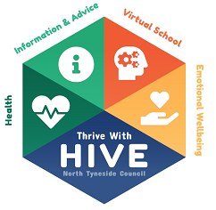
Every looked after child / young person from aged 3 (first term after 3rd birthday) up to the age of 18 requires a PEP.
When a child enters care, a PEP has to be completed within 10 school days.
PEPs are completed in the Autumn Term (before the end of November) and are reviewed in the Spring Term (before the end of February) and the Summer Term (before the end of May).

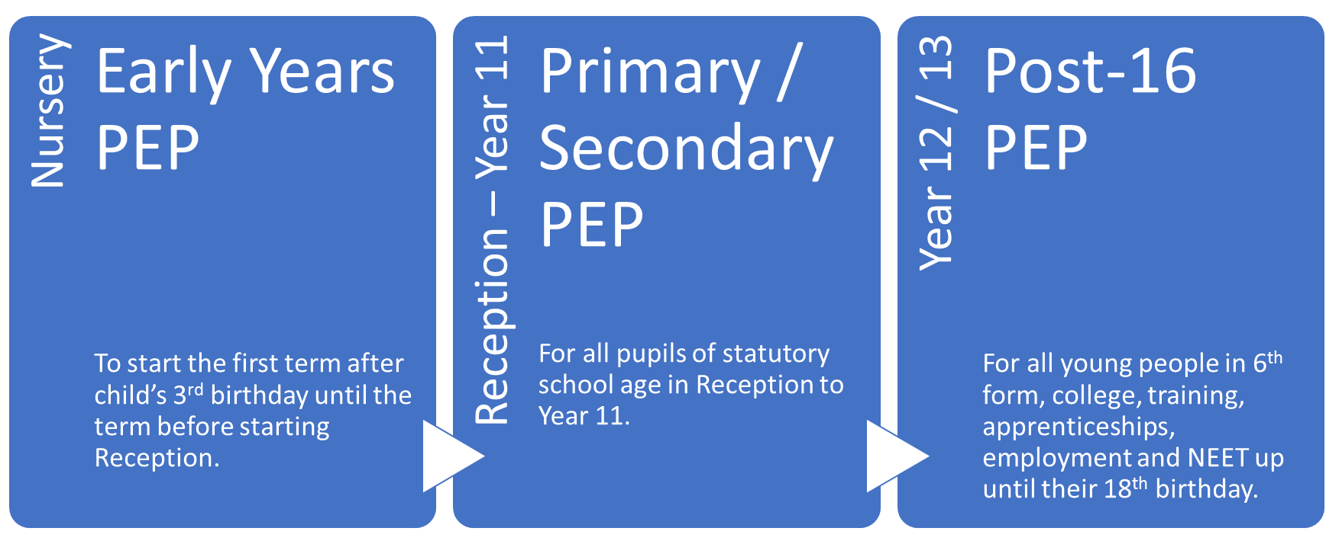
There are 3 different PEPs for different age groups:

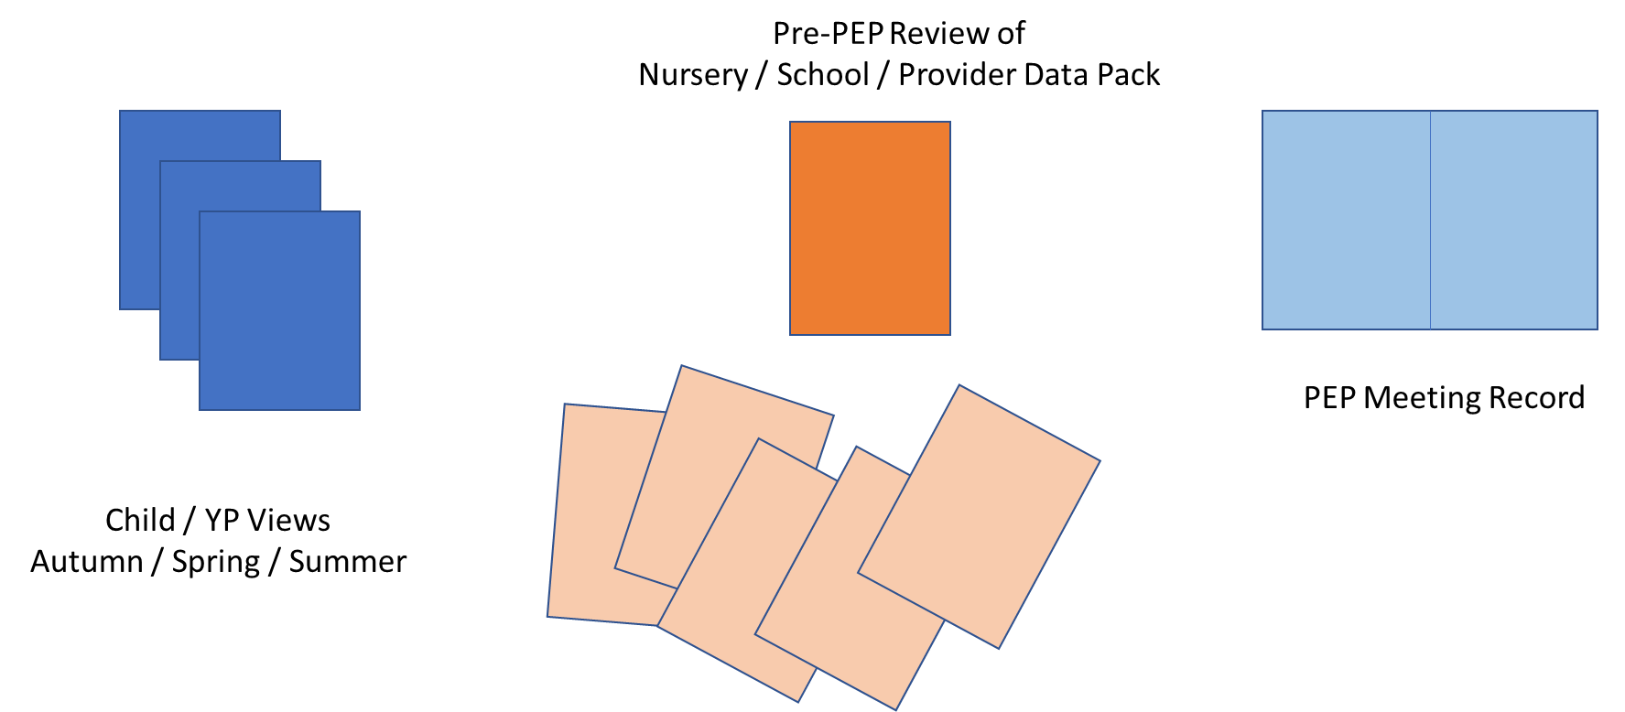
There are three parts to each PEP:

School / Nursery / Provision Staff Role in PEP Process
Prior to PEP Meeting | Agrees date with social worker, carer and pupil (if appropriate) for PEP meeting (Social worker should initiate PEP if child new into care, to be completed within 10 school days).  Book room for meeting.  Supports Child / Young Person to complete their Views and invite to meeting (if appropriate).  Prints out the Data Pack (reports, attendance data, behaviour record, SEN info, Pupil Premium etc) and completes review and analysis.
During PEP Meeting | Chairs PEP meeting and leads discussion based on pupil views and data pack review. Sets goals and agrees actions with others in meeting.  Shares Pupil Views and Data Pack with social worker at end of meeting.  Agrees date for PEP review (Spring Term / Summer Term)
After PEP Meeting | Completes any actions agreed to achieve goals.

