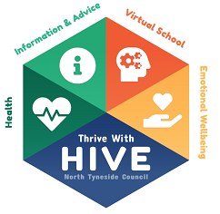
Quick PEP Guide for Social Workers
Every looked after child / young person from aged 3 (first term after 3rd birthday) up to the age of 18 require a PEP.
When a child enters care, a PEP has to be completed within 10 school days.
PEPs are completed in the Autumn Term (before the end of November) and are reviewed in the Spring Term (before the end of February) and the Summer Term (before the end of May).

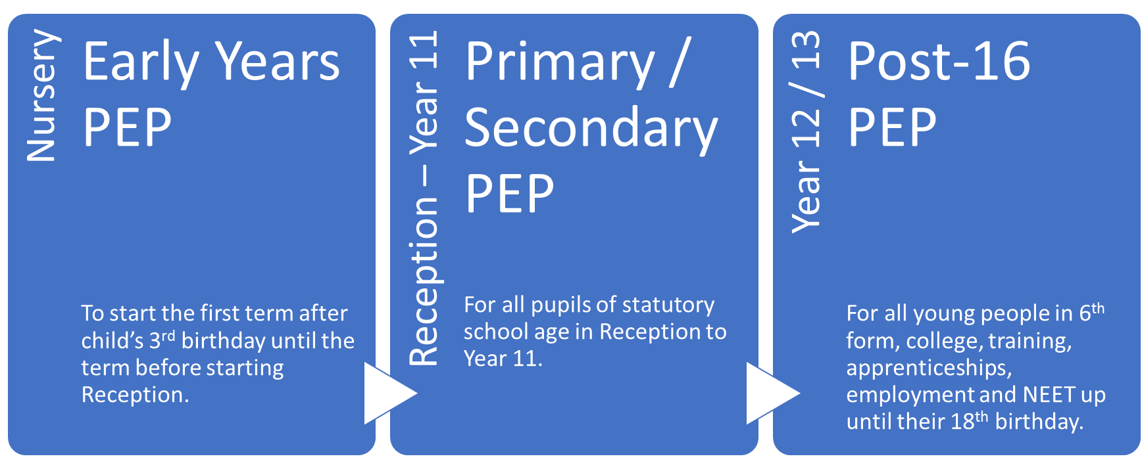
The are 3 different PEPs for different age groups:

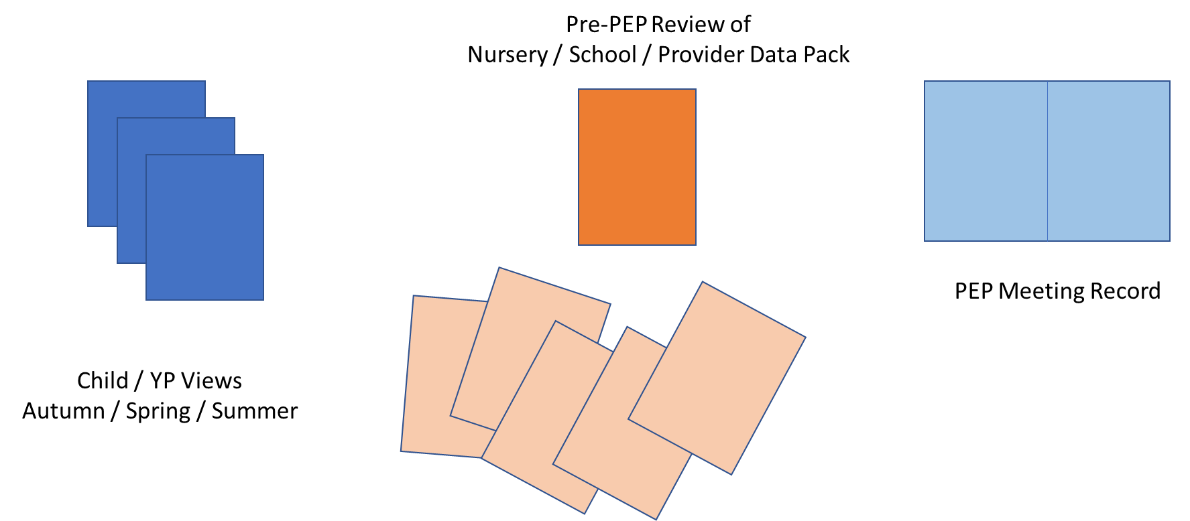
There are three parts to each PEP:

Social Worker Role in PEP Process
Prior to PEP Meeting | Agrees date with school and carer for PEP meeting (initiates PEP if child new into care and completes within 10 school days)  Reads previous PEP.
During PEP Meeting | Attends PEP meeting and records discussion on PEP Meeting Record (electronically if possible)  Collects Pupil Views and Data Pack from school at end of meeting.  Agrees date for PEP review (Spring Term / Summer Term)
After PEP Meeting | Scans in Pupil View and Data Pack to LCS, completes meeting date and uploads PEP Meeting Record.  Completes any actions agreed to achieve goals.

