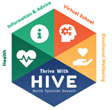
School Age PEP (Reception to Year 11)
Pupil Views (Version B )
Spring 2021
Name:
Date Completed:

You’re nearly half-way through the academic year!
If we are in lockdown when this PEP is completed please fill in:
Are you being educated in school or at home?
Do you need any additional resources or support?

Which lessons have you been enjoying most this year and why?
What helps you to concentrate in class?
Are there any lessons you need more help with?
Do you manage to complete your homework on time? If not, what might help?
Do you take part in any sporting activities (when not in Covid restrictions)? If not, is there anything you would like to do?
Do you play a musical instrument? If not, would you like to?
What books do you like to read and why do you like them?
Do you have an adult you can talk to in school and who is this?

