Nursery PEP

Child’s Views

Autumn 2020

My Name is ____________________________

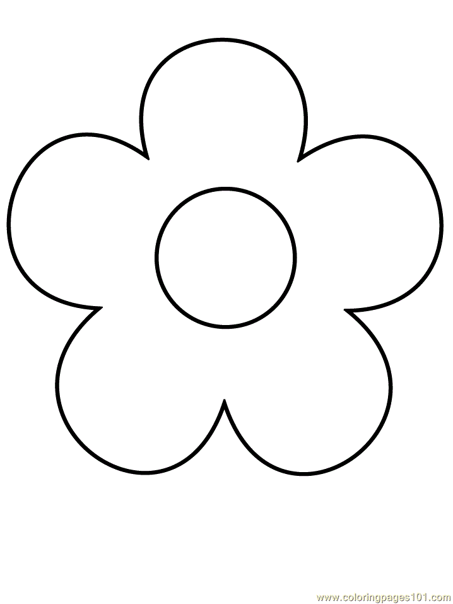

My favourite books

My favourite games

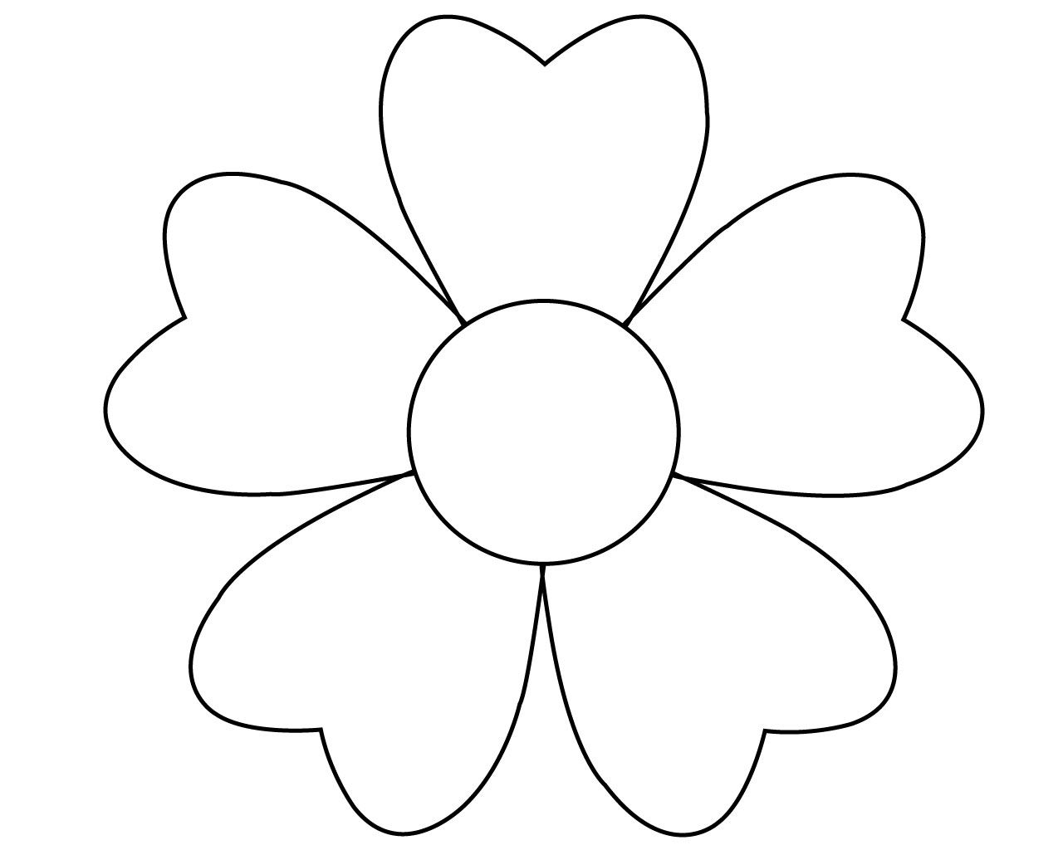

What makes me worried

What makes me happy

