Post 16 - Personal Engagement Plan
Post-16 Re-engagement PEP
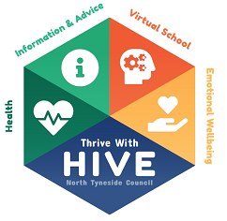
Please complete this PEP for young people identified as currently not in education, training or employment.
This document should be reviewed in 6 weeks’ time to check short term goals have been completed. It should then be reviewed every 6 weeks until young person is re-engaged in education, employment or training.
Please complete the following with the young person, detailing their information.
Name

Date of Birth

Accommodation Type

Social Worker/Leaving Care Worker/other workers involved
Contact details if you want someone to contact you about further support (phone or email)

Qualifications achieved so far (including Level)
Please give details of any education, training or employment you have undertaken since you left school.

Did you leave any of them before the end of the course / contract? If so, why was this?
Do you have your own ideas about what you would like to do next in terms of education, training or employment?
What advice or guidance have you already received in terms of your next step options?

What advice or guidance would you like, or think you need, in terms of your next step options?

What are your interests?
What are your strengths?

What is going well at the moment?

What do you think is preventing you from undertaking your chosen next steps in relation to education, training or employment? | What support do you need in order to overcome this? Who can help?

My Short Term Goal/s (in 6 weeks’ time): | What I need to do | What I need others to do
My Long Term Goal/s (in 1 years’ time):
My Life Goals  (in 15 years’ time) | What will help me achieve my dreams?

Date Completed:

Signed:

Date for review (6 weeks):

