School Age PEP (Reception to Year 11)
Pupil Views (Version B Advanced )
Autumn 2021
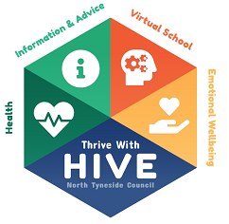
Name:
Date Completed:

What is going well since returning to school?
What are you most looking forward to this year?
Is there anything you are worried or concerned about?
Who helps you in school and what do they do to help? Is there anything else you need support with?
What career are you interested in going into in the future? Is there anything you need to support you with this?
What makes you happy at school?
What do you do out of school to look after your mental health and emotional wellbeing?

