School Age PEP (Reception to Year 11)
Pupil Views (Version A Basic )
Autumn 2021
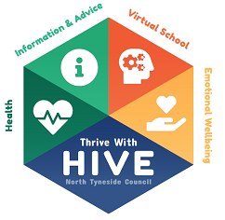
Name:
Date Completed:

What is going well since returning to school?
Is there anything you are worried or concerned about?
Who helps you in school and what do they do to help?
What job would you like to do when you’re older?
What makes you happy at school?

