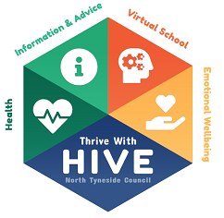
Post 16 PEP
Young Person’s Views
Autumn 2021
Name:
Date Completed:

What are you studying this year? At what level?
What are you enjoying about it?
Is there anything you are not happy about or worried about?
What are you hoping to do after this course?
Next:

In 5 years time:

Have you got what you need to access online learning at home if needed?
What helps you to concentrate in class? At home?
What can others do to help you? (Friends, staff at education provision, carer, social worker, HIVE Team)
Anything else you wish to mention?

