
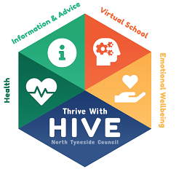
Academic Year 2025 – 26
Post 16 RE-engagement plan
Personal Engagement Plan
Name:

Post 16 - Personal Engagement Plan
Please complete this PEP for young people identified as currently not in education, training or employment.
This document should be reviewed in 6 weeks’ time to check short term goals have been completed. It should then be reviewed every 6 weeks until young person is re-engaged in education, employment or training.
Please complete the following with the young person, detailing their information.
Name

Date of Birth |  | Age
Accommodation Type

Social Worker/Future Foundations PA /other workers involved
Contact details if you want someone to contact you about further support (phone or email)

What have you already achieved?
Subject | Type of Qualification – GCSE / Functional Skills / Other | Grade
Maths
English
Other:
Other:
Other:
Other:

Please give details of any education, training or employment you have undertaken since you left school.

Did you leave any of them before the end of the course / contract? If so, why was this?
Do you have your own ideas about what you would like to do next in terms of education, training or employment?
Have you been offered any work experience? If yes, what was it and how did it go? If no, is this something you would be interested in?
What advice or guidance have you already received in terms of your next step options? Any further advice you’d like?

What are your interests?

What are your strengths?

What is going well at the moment?

Overcoming Barriers
What do you think is preventing you from taking the next steps in relation to education, training or employment? | What support do you need in order to overcome this? Who can help?

Goal Setting
My Short Term Goal/s (in 6 weeks’ time): | What I need to do | What I need others to do
My Long Term Goal/s (in 1 years’ time):
My Life Goals  (in 15 years’ time) | What will help me achieve my dreams?

Date of review | Progress on overcoming barriers and short-term goals

Date Completed:

Signed:

Date for review (6 weeks):

